ABSTRACT

In many of the educational institutions, managing attendance of students/candidates is tedious, as there would be large number of students in the class and keeping track of all is onerous. There are situations where student act as proxies for their friends even though they are not present. The advancement in the history of computer vision utilizing deep learning approaches especially convolutional neural networks have accomplished to solve difficult problems in face recognition field. Face recognition-based approach is one amongst the important identification methods which can be used as a possible substitution for conventional system of marking attendance manually, especially if a huge classroom of students is addressed for an hour session. Our solutions integrate AI capabilities with smart analytics features to facilitate transparency in classrooms and college campus. This project develops an automatic attendance system using Faster R-CNN deep learning based algorithm. In this system, a database containing the trained student’s face. A camera installed in the college campus captures the face of all the student in the classroom and other places too. This face image is processed using FRCNN algorithms to detect faces and to mark the attendance automatically in an excel sheet. The system records the entire class session and identifies when the students pay attention in the classroom, and then reports to the facilities and also this system can record violations of classroom, that is absence, roaming around the college campus during the class hours and send alert message to the H.O.D. This dynamic attendance system uses face recognition as an important aspect of taking attendance which saves time and proxy attendance and is avoided. The system identifies faces very fast needing only 100 milliseconds to one frame and obtaining a high accuracy. Our face recognition model has an accuracy rate of 98.87%.

TABLE OF CONTENTS
S. NO | TITLE | PAGE NO
 | ABSTRACT | iv
 | ABSTRACT TAMIL | v
 | LIST OF FIGURES | vii
 | LIST OF ABBREVIATION | viii
1 | INTRODUCTION | 1
 | 1.1. Overview | 1
 | 1.2. Problem Statement | 2
 | 1.3. Deep Learning: Faster – RCNN | 3
 | 1.4. Aim and Objective | 7
 | 1.5. Scope of the Project | 7
2 | LITERATURE SURVEY | 9
3 | SYSTEM ANALYSIS | 12
 | 3.1. Existing System | 12
 | 3.2. Proposed System | 14
 | 3.3. Algorithm | 16
4 | SYSTEM SPECIFICATION | 20
 | 4.1. Hardware Requirements | 20
 | 4.2. Software Requirements | 20
 | 4.3. Software Description | 21
5 | SYSTEM ARCHITECTURE | 32
 | 5.1. System Flow Diagram | 32
6 | SYSTEM TESTING | 33
 | 6.1. SYSTEM TESTING | 33
7 | IMPLEMENTATION | 41
 | 7.1. Project Description | 41
 | 7.2. Module Description | 42
8 | CONCLUSION & FUTURE ENHANCEMENT | 51
9 | APPENDIX-I | 52
 | Sample Coding | 52
10 | APPENDIX-II | 58
 | 10.1 Screen Shots | 58
11 | REFERENCES | 59

LIST OF DIAGRAMS

FIGURAE NO | DIAGRAMS | PAGE NO.
1.1 | Attendance Representation | 1
1.2 | Attendance Management System | 2
1.3 | Artificial Intelligence | 3
1.4 | Deep neural network architecture | 4
1.5 | Forward Propagation in Neural Networks | 4
1.6 | Convolutional Neural network | 5
1.7 | Faster R-CNN | 6
3.1 | Proposed System | 15
4.1 | Python Programming | 21
4.2 | Tensor Flow | 22
4.3 | Keras | 23
4.4 | Pandas | 23
4.5 | Numpy | 24
4.6 | Matplotlib | 24
4.7 | Machine Learning & Python | 24
4.8 | Pillow | 25
4.9 | OpenCV | 25
4.10 | MySQL | 26
4.11 | WampServer | 27
4.12 | Bootstrap | 27
4.13 | Flask | 28
4.14 | SMS API | 29
4.15 | SMTP | 30
5.1 | System Architecture | 32
6.1 | Software Testing | 33
6.2 | Types of Testing | 34

LIST OF ABBREVIATION
CNN | Convolutional Neural Network
RFID | Radio-Frequency Identification
R-CNN | Region-based CNN
RPN | Region Proposal Network
SVM | Support Vector Machine
PVA | Principal Component Analysis
RoI | Region of Interest

CHAPTER 1

INTRODUCTION
1.1. OVERVIEW
Attendance is the act of being present at or attending a class, an event or a meeting. It depends upon the classroom, whether the attendance would be both physical and virtual. In schools, students must maintain their attendance against a set standard. The concept of students appearing in the classroom to attend the lecture is called class attendance. Class Teachers count all the students by their name and record the information in a register or digital software.

Fig 1.1 Attendance Representation
There are various methods of taking attendance like biometric systems using student identification cards or fingerprints, physical presence is recorded in registers or software tools. During online classes, the teacher marks online attendance to ensure the presence of all the students.
As per school policy, the attendance of students affects their grades. Sometimes, students’ absenteeism from school has various reasons. Some of these reasons can be a bad company, personal issues, health issues, family problems, bullying, etc. Keeping a tab on absenteeism helps to identify the reasons behind a student’s absence from school. When recognized, teachers can work in that direction to improve a student’s situation. There are various methods of taking attendance like biometric systems using student identification cards or fingerprints, physical presence is recorded in registers or software tools. During online classes, the teacher marks online attendance to ensure the presence of all the students.
Attendance Management System

A software program or platform called an attendance management system for students is made to track and keep track of students' attendance in educational institutions including schools, colleges, and universities. Its main objective is to automate and streamline the process of monitoring student attendance in order to ensure accuracy and effectiveness for both students and staff.
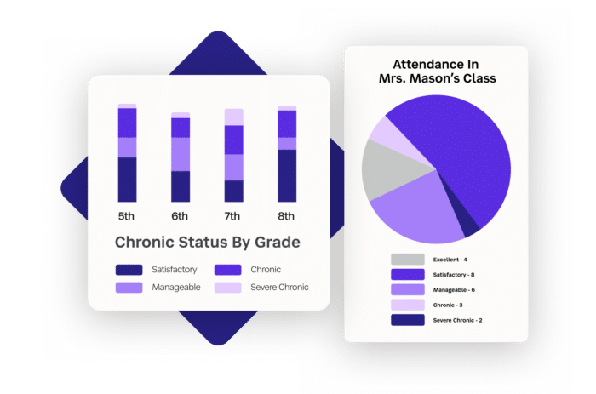
Fig 1.2 Attendance Management System

Student Attendance Management System is a digital platform designed to efficiently record and monitor the attendance of students in educational institutions. It automates the process of tracking student attendance, making it easier for teachers, administrators, and parents to access real-time attendance information. Its main objective is to automate and streamline the process of monitoring student attendance in order to ensure accuracy and effectiveness for both students and staff.

1.2. PROBLEMS STATEMENT

Attendance plays a pivotal role in academic performance of students in schools and colleges. The consistent absence from class increases the risk of failure and early dropout. Attendance check is an efficient way to improve the attendance rate of a student in a class. The traditional methods include calling names or signing on papers, which is highly time-consuming and insecure. To solve the issues associated with traditional attendance check methods, different types of automated attendance systems have been developed using different technologies. In the fingerprint-based attendance system, a portable fingerprint device is required to collect and recognize students’ fingerprints to mark their attendances. In the RFID-based attendance system, students need to present their RFID cards to an ID card reader to record their presences. In the Iris-based attendance system, a camera scans the Iris of students, which will be used to match the Iris database of students, and to update the attendance of students. Recently, face recognition-based attendance systems are getting more attentions. Video surveillance is a technology that is unobtrusive and can promote security beginning at the outermost boundaries of the school environment – at the perimeter and as automobiles drive onto college grounds. Furthermore, incorporating new artificial intelligence (AI) and deep learning technologies are increasing the real-time capabilities of video surveillance to provide early warning. AI and deep learning analyse the content of video feeds and provide usable information to security personnel, including analysis of trends and real-time alarms when an event takes place.

1.3. DEEP LEARNING

Deep Learning is a subset of Machine Learning, which on the other hand is a subset of Artificial Intelligence. Artificial Intelligence is a general term that refers to techniques that enable computers to mimic human behaviour. Machine Learning represents a set of algorithms trained on data that make all of this possible.
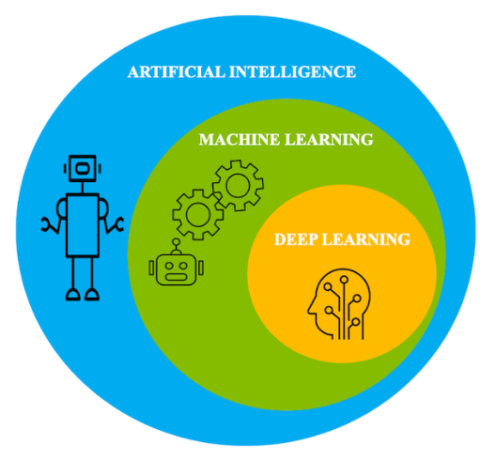
Fig 1.3 Artificial Intelligence

1.3.1. Deep neural networks

A deep neural network is simply a shallow neural network with more than one hidden layer. Each neuron in the hidden layer is connected to many others. Each arrow has a weight property attached to it, which controls how much that neuron’s activation affects the others attached to it.The word ‘deep’ in deep learning is attributed to these deep hidden layers and derives its effectiveness from it. Selecting the number of hidden layers depends on the nature of the problem and the size of the data set. The following figure shows a deep neural network with two hidden layers.
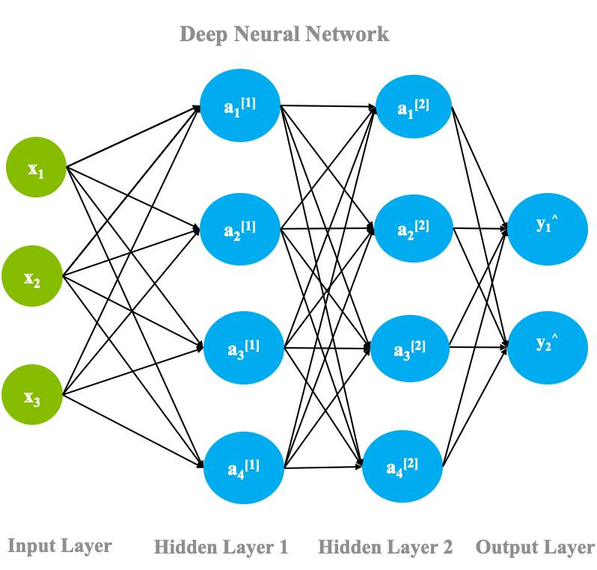
Figure 1.4. Deep neural network architecture

The data is fed into the input layerEach node in the input layer ingests the data and passes it onto the next layer, i.e., the hidden layers. These hidden layers increasingly extract features from the given input layer and transform it using the linear function. These layers are called hidden layers because the parameters (weights and biases) in each node are unknown; these layers add random parameters to transform the data, each of which yields different output. The output yielded from the hidden layers is then passed on to the final layer called the output layer, where depending upon the task, it classifies, predicts, or generates samples.
This process is called forward propagation.
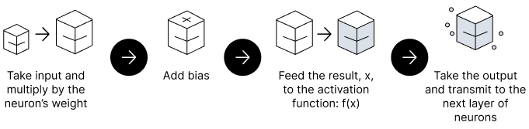
Figure 1.5. Forward Propagation in Neural Networks

Forward propagation in neural networks.In another process called backpropagation, an algorithm, like gradient descent, calculates errors by taking the difference between the predicted output and the original output. This error is then adjusted by fine-tuning the weights and biases of the function by moving backward through the layers. Both, the process of forward propagation and backpropagation allows a neural network to reduce the error and achieve high accuracy in a particular task. With each iteration, the algorithm becomes gradually more accurate.

1.3.2. Types of neural networks
There are several types of neural networks.
1. CNN
The Convolutional Neural Networks or CNNs are primarily used for tasks related to computer vision or image processing.

CNNs are extremely good in modelling spatial data such as 2D or 3D images and videos. They can extract features and patterns within an image, enabling tasks such as image classification or object detection.

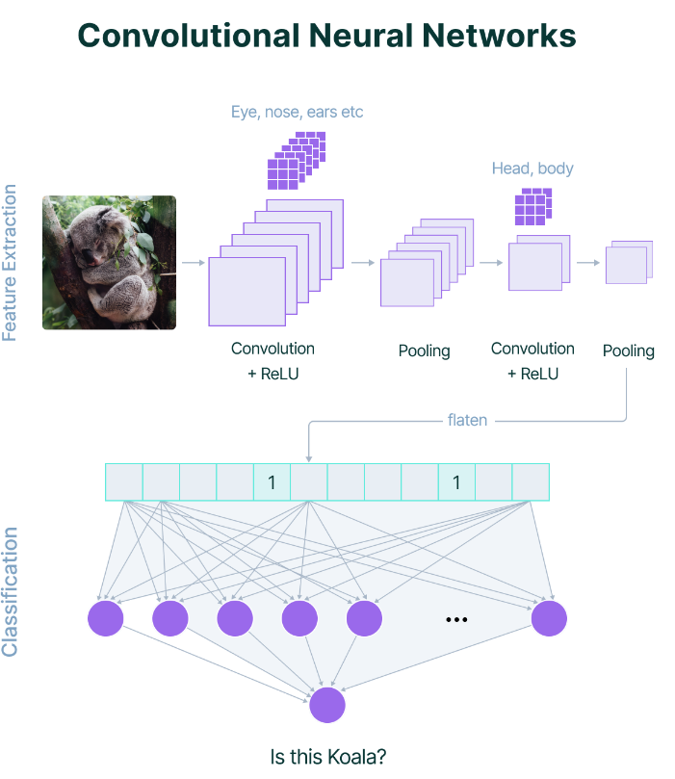
Fig 1.6. Convolutional Neural network

Faster – Region Convolutional Neural network
Faster R-CNN is an extension of Fast R-CNN. As its name suggests, Faster R-CNN is faster than Fast R-CNN thanks to the region proposal network (RPN).The architecture of Faster R-CNN is shown in the next figure. It consists of 2 modules:

- RPN: For generating region proposals.
- Fast R-CNN: For detecting objects in the proposed regions.

The RPN module is responsible for generating region proposals. It applies the concept of attention in neural networks, so it guides the Fast R-CNN detection module to where to look for objects in the image.
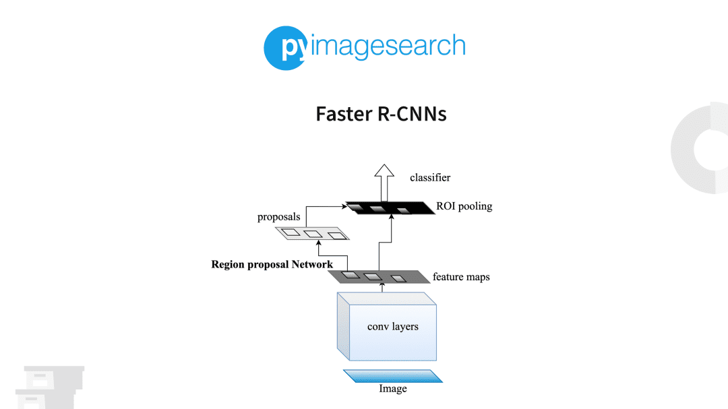
Fig 1.7 Faster R-CNN

The Faster R-CNN works as follows:
- The RPN generates region proposals.
- For all region proposals in the image, a fixed-length feature vector is extracted from each region using the ROI Pooling layer.
- The extracted feature vectors are then classified using the Fast R-CNN.
- The class scores of the detected objects in addition to their bounding-boxes are returned.

Use a 3 x 3 convolutional layer with padding of 1 to transform the CNN output to a new output with channels. In this way, each unit along the spatial dimensions of the CNN-extracted feature maps gets a new feature vector of length c. centred on each pixel of the feature maps, generate multiple anchor boxes of different scales and aspect ratios and label them. Using the length-c feature vector at the centre of each anchor box, predict the binary class (background or objects) and bounding box for this anchor box. Consider those predicted bounding boxes whose predicted classes are objects. Remove overlapped results using non-maximum suppression. The remaining predicted bounding boxes for objects are the region proposals required by the region of interest pooling layer. It is worth noting that, as part of the faster R-CNN model, the region proposal network is jointly trained with the rest of the model. In other words, the objective function of the faster R-CNN includes not only the class and bounding box prediction in object detection, but also the binary class and bounding box prediction of anchor boxes in the region proposal network. As a result of the end-to-end training, the region proposal network learns how to generate high-quality region proposals, so as to stay accurate in object detection with a reduced number of region proposals that are learned from data.

1.4. OBJECTIVE

The aim of this project is to implement an advanced AI-based College Surveillance System incorporating Faster R-CNN and FaceNet technologies. The system aims to revolutionize attendance management, enhance campus security, and provide valuable behavioural insights in educational institutions. To automate attendance tracking for efficient and accurate record-keeping. To implement behavioural analysis for identifying patterns such as class skipping or unusual activities. To integrate FaceNet for precise face recognition and secure campus access.
To develop a Violation Alert module to identify and notify about attendance violations and unauthorized access. To create a comprehensive notification system for stakeholders' awareness and communication. To design a centralized College Admin Dashboard for efficient management of departments, semesters, and student information. To develop user interfaces for College Admin, Staff, and HoD roles with tailored functionalities. To implement the FaceNet model, involving video capture, preprocessing, face detection, feature extraction, CNN-based face recognition, and deployment with Faster R-CNN. To develop a Face Identification module for real-time face recognition in classrooms and campus areas. To automate attendance marking based on identified faces with real-time updates.To enhance user engagement through a user-friendly interface.To strengthen campus security with advanced technologies to detect and respond to potential threats.

1.5. SCOPE OF THE PROJECT

The project aims to implement an AI-based College Surveillance System, integrating Faster R-CNN and FaceNet technologies. It focuses on automating attendance management through precise facial recognition, implementing behavioural analysis for proactive intervention, and enhancing campus security with advanced features. The system includes a centralized administrative dashboard, tailored user interfaces, and a comprehensive notification system for efficient communication. Real-time face identification and automation of attendance processes are key objectives, contributing to a user-friendly interface and strengthening overall campus security.

CHAPTER 2

LITERATURE SURVEY

The different AI-based surveillance systems that focus on attendance tracking and performance evaluation therefore provide improvements for institutional management. AI-Based systems such as facial recognition and machine learning automate attendance calling; other systems such as AI enabled CCTVs can assure entry-exit tracking. Our Student Surveillance System does not focus solely on attendance but options for real-time face recognition to enforce discipline, identification card detection, and behavioral analysis. This monitors dress code violations and unauthorized movements, minimizing manual checks, and ensuring automated rule enforcement. This boosts security and compliance, especially within the campus. An open-world deep face recognition approach was suggested using their Roll based metric learning method.
[1] presented an adaptive threshold algorithm and a new performance measure for dealing with imbalanced data, improving recognition time and accuracy. A high-accuracy real-time monitoring system was designed to identify criminal faces from video recordings. Kim et al. [2] combined face detection, tracking, and deep face recognition methods to compare people against a database of known criminals for enhanced crime prevention. The approach involves RetinaFace for face detection, SORT for tracking, and FaceNet for feature extraction. A multi-camera, multi-vehicle tracking system was proposed for smart transportation networks. Nguyen et al.
[3] utilized graph-based tracklet features to preserve association data between multiple camera views, addressing the limitations of conventional tracking approaches. The system utilizes YOLOv5 for object detection, FairMOT for multi-object tracking, and graph-based trackless feature building for enhanced accuracy. Security weaknesses of deep learningbased surveillance systems, especially in the context of adversarial attacks, were explored. Panigrahy et al.
[4] emphasized face mask detection models and needed proactive defense measures. The system that was proposed used ShuffleNet V1, ResNet-10 SSD, and FGSM for protecting against possible vulnerabilities while ensuring real-time detection. Multi-pose face recognition in real-time video streams has been challenged through the creation of a system with high accuracy and real-time operation. Sohail et al.
[5] utilized YOLOv5 to perform face detection with different poses so that the possibility of missing prospective matches due to pose changes would be minimized, and the technique would be greatly effective for practical surveillance use. Real-time object detection in urban environments is a very important area of research for surveillance applications.
[6]. The study presented in utilized the YOLO model for real-time detection and monitoring, which showed good accuracy and fast processing speed. The proposed method also demonstrates potential against varying object density and scene conditions for surveillance-based applications, such as student monitoring in an educational setting. The development of UAV surveillance systems for facial recognition and tracking has mostly dealt with GPS-denied environments. The integrations with facial recognition also allow the application of a custom UAV system to track individuals which consequently improves the accuracy of identification, as shown in
[7]. The methodology itself focuses on realtime tracking; this characteristic is important in automated surveillance solutions where identification and monitoring of students are concerned. Automated detection systems with video surveillance have seen enormous and vast applications throughout the world to ensure compliance.
[8].Puts forth an Automatic Compliance System for Face Mask Detection powered by AI, capturing video surveillance in people, thus verifying compliance automatically. This is similar to automated dress code monitoring, wherein rules of compliance can be fed into the system and checked by applying intelligent image recognition techniques.
[9].Employs CNN for facial recognition and YOLO for violation detection comprising ID cards and shoes within the dress code. This mechanism would somewhat justify automated uniform compliance systems, as it allows one to gain smart violations to enforce in real-time. Efficient human detection and tracking surely take paramount significance in surveillance-based systems.
[10]. It is suggested to employ YOLOv3-Tiny on FPGA for fast and accurate human detection for real-time applications. This approach fostered the ideals of computational efficiency, which is much needed in extensive monitoring systems like student compliance tracking. A methodology for multi-stage object and face detection has been examined that involves CNN-based models.
[11].Integrates deep-learning techniques such as CNN, SVM, and logistic regression models within itself to increase authenticity in recognizing targets. With improved detection efficacy, the system provides a solution to surveillance applications for reliable recognition in student monitoring systems. The integration of real-time face recognition is implemented in robotic systems using deep learning models in this study.
[12]. The integration of YOLO5 for face detection in an NAO robot enables its ability to achieve a high recognition rate under varying lighting conditions. Such techniques contribute to automated surveillance systems, ensuring efficient real-time recognition of students for compliance monitoring. These studies offer effective information regarding the development of surveillance systems by suggesting significant methodologies, strengths, and issues in real-world implementations.

CHAPTER 3
SYSTEM ANALYSIS
3.1. EXISTING SYSTEM
Manual attendance calling, self-reporting attendance systems (using tools like Google forms), video calling students, short quizzes or polls, questions and discussions by selecting random students, and timed assignments. In the case of physical classrooms, biometric-based attendance monitoring systems are essentially based on face, fingerprint, and iris recognition technologies Facial recognition is a technology that is capable of recognizing a person based on their face. It employs machine learning algorithms which find, capture, store and analyses facial features in order to match them with images of individuals in a pre-existing database. Early approaches mainly focused on extracting different types of hand-crafted features with domain experts in computer vision and training effective classifiers for detection with traditional machine learning algorithms. Such methods are limited in that they often require computer vision experts in crafting effective features, and each individual component is optimized separately, making the whole detection pipeline often sub-optimal. There are many existing FR methods that achieve a good performance

SUPPORT VECTOR MACHINE (SVM)
Support Vector Machines (SVM) are a popular training tool which can be used to generate a model based on several classes of data, and then distinguish between them. For the basic two-class classification problem, the goal of an SVM is to separate the two classes by a function induced from available examples. In the case of facial recognition, a class represents a unique face, and the SVM attempts to find what best separates the multiple feature vectors of one unique face from those of another unique face.

PRINCIPAL COMPONENT ANALYSIS (PCA)
One of the most used and cited statistical method is the Principal Component Analysis. A mathematical procedure performs a dimensionality reduction by extracting the principal component of multi-dimensional data. Principal component analysis id reducing the Eigen value and Eigen vectors problem in a matrix. Simply Principal component analysis is used for a wide range of variety in different applications such as Digital image processing, Computer vision and Pattern recognition. The main principal of principal component analysis is reducing the dimensionality of a database. In the communication of large number of interrelated features and those retaining as much as possible of the variation in the database

LINEAR DISCRIMINANT ANALYSIS (LDA)
LDA is widely used to find the linear combination of features while preserving class separateability. Unlike PCA, the LDA tries to model to the difference between levels. For each level the LDA obtains differenced in multiple projection vectors. Linear discriminate analysis method is related to fisher discriminate analysis. Linear discriminate analysis is using to describing the local features of the images. Features are extracting the form of pixels in images; these features are known as shape feature, color feature and texture feature. The linear discriminate analysis is using for identifying the linear separating vectors between features of the pattern in the images. This procedure is using maximization between class scatter, when minimizing the intra class variance in face identification.

NEURAL NETWORK (NN)
Neural Network has continued to use pattern recognition and classification. Kohonen was the first to show that a neuron network could be used to recognize aligned and normalized faces. There are methods, which perform feature extraction using neural networks. There are many methods, which combined with tools like PCA or LCA and make a hybrid classifier for face recognition. These are like Feed Forward Neural Network with additional bias, Self-Organizing Maps with PCA, and Convolutional Neural Networks with multi-layer perception, etc. These can increase the efficiency of the models.

K-NEAREST NEIGHBORS
One of the basic classification algorithms in machine learning is known to be the k-NN algorithm. In machine learning, the k-NN algorithm is considered a well monitored type of learning. It is commonly used in the sorting of related elements in searching apps. By constructing a vector representation of objects and then measuring them using appropriate distance metrics, the similarities between the items are determined.

OTHER APPLICATION USED FR
- Face Recognition Applications are Security System and Smart Home Automation System.
- Face recognition-based voting system are proposed

3.1.1. DRAWBACKS
- Calling students' names in virtual classrooms to take attendance is both trivial and time-consuming.
- Students may resort to unethical activities like not attending the class but still keeping their status as `online’.
- Student can go offline at any time without letting the teacher know.
- It is not easy to find out whether the student is really attending the class.
- Student might have turned off the video camera.
- All the existing process will consume valuable lecturing time and will affect the teaching efficiency.
- The accuracy of the system is not 100%.
- Face detection and loading training data processes just a little bit slow.
- It can only detect face from a limited distance.
- The instructor and training set manager still have to do some work manually.
- Handcrafted feature
- High Computational Complexity

3.2. PROPOSED SYSTEM
This paper proposed a system that can automatically attend using surveillance cameras. The camera will be installed in front of the class in an area that can reach all parts of the class and other area of the campus including vehicle stand, canteen, seminar hall, library etc. Propose a deep unified model for Face Recognition based on Faster Region Convolution Neural Network. Furthermore, by using a face detection system, the camera will mark the part of the frame from the captured image which is the face of students in a class and other area. The process is continued with an introduction to the face that has been detected so that it will automatically be kept a record that the student is present in the class or outside the class with a specific course and time.
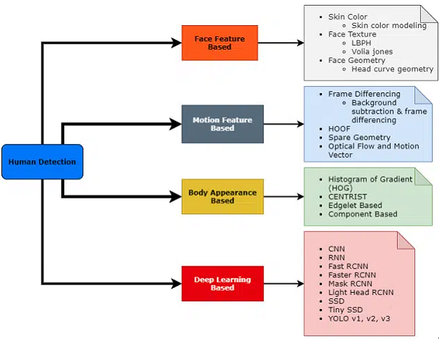
Fig3.1 Proposed System

FACENET MODEL INTEGRATION
The FaceNet model is seamlessly integrated, involving video capture, frame preprocessing, face detection, feature extraction, CNN-based face recognition, and deployment with Faster R-CNN. This ensures high accuracy in face identification.

REAL-TIME FACE IDENTIFICATION MODULE
A dedicated module enables real-time face identification during live video feeds in classrooms and campus areas. This contributes to the overall automation of attendance processes, enhancing efficiency.

FACE RECOGNITION AND ATTENDANCE AUTOMATION
The system utilizes FaceNet for precise face recognition, enabling automated attendance tracking. Real-time identification during class hours ensures accurate and efficient attendance management.

BEHAVIORAL ANALYSIS WITH FASTER R-CNN
Faster R-CNN is employed for behavioral analysis, detecting patterns like class skipping or unusual activities. This feature provides administrators with proactive insights into student engagement and potential challenges.

VIOLATION ALERT SYSTEM
The system includes a Violation Alert module to detect unauthorized activities, such as students wandering during class hours. Administrators receive instant alerts with time stamped images, facilitating prompt intervention.

COMPREHENSIVE NOTIFICATION SYSTEM:
A robust notification system keeps stakeholders informed about attendance events, violations, and critical updates. Notifications, delivered through SMS, emails, or in-app messages, enhance communication within the educational community.

3.2.1. ADVANTAGES
- Precision in Attendance Tracking through FaceNet technology
- Proactive Intervention with Behavioral Analysis using Faster R-CNN
- Heightened Campus Security via Face Recognition and Violation Alerts
- Efficient Administrative Oversight with Centralized Dashboard and Tailored User Interfaces
- Real-time Face Identification for Automated Attendance
- Transparent Communication facilitated by Robust Notification System
- User-Friendly Interfaces for Different Roles
- Advanced Technological Integration with Faster R-CNN and FaceNet
- Time Efficiency in Attendance Processes through Automation
- Data-Driven Decision Making for Administrators
- Secure Campus Environment with Face Recognition and Violation Alerts
- Adaptability and Scalability for Various Educational Settings

3.3. ALGORITHM
3.3.1. FRCNN
The Faster Region Convolutional Neural Network (Faster R-CNN) is a powerful object detection algorithm that combines deep learning with region proposal networks for efficient and accurate detection. Here is a step-by-step overview of the Faster R-CNN algorithm:
- Input Frames:
  - The process begins with the input image, which is the target for object detection. The goal is to identify and locate objects within this image.

- Convolutional Backbone (Feature Extraction):
  - The input image passes through a convolutional neural network (CNN) to extract features. This network, often pre-trained on a large dataset, captures hierarchical features at different scales.

- Region Proposal Network (RPN):
  - The RPN operates on the feature map obtained from the convolutional backbone. It generates region proposals, which are potential bounding boxes around objects. These proposals are generated based on anchor boxes and their associated scores.

- Anchor Boxes:
  - Anchor boxes are predefined bounding boxes of various scales and aspect ratios. The RPN suggests potential regions based on sliding these anchor boxes over the feature map.

- Region of Interest (RoI) Pooling:
  - The proposed regions from the RPN are refined using RoI pooling. This step extracts fixed-size feature maps from each region proposal, allowing for consistent input sizes to the subsequent layers.

- Fully Connected Layers:
  - The RoI-pooled feature maps are passed through fully connected layers to further refine and classify the proposed regions. These layers make predictions regarding the class of the object within each region and fine-tune the bounding box coordinates.

- Bounding Box Regression:
  - Bounding box regression is applied to adjust the coordinates of the proposed bounding boxes. This step refines the localization of the detected objects.

- Non-Maximum Suppression (NMS):
  - To eliminate redundant and overlapping detections, non-maximum suppression is employed. This process selects the most confident and accurate detections while discarding others.

- Output:
  - The final output includes the detected objects along with their corresponding bounding boxes and confidence scores. This information provides a comprehensive understanding of the objects present in the input image.Faster R-CNN's strength lies in its ability to integrate region proposal and object detection into a single unified framework. By leveraging deep learning for both feature extraction and region proposal, it achieves state-of-the-art performance in object detection tasks.

3.3.2. FaceNet Model
- Input Frames:
  - The FaceNet model starts with a dataset of facial images. These images should be labeled with the identities of the individuals.

- Face Detection:
  - Employ a face detection algorithm to locate and extract faces from the images. This step is crucial for isolating the facial features for subsequent processing.

- Image Preprocessing:
  - Preprocess the extracted facial images, including resizing, normalization, and potentially alignment, to ensure standardized inputs for the model.

- Triplets Sampling:
  - For training, FaceNet uses triplets of images for each example. A triplet consists of an anchor image (the reference face), a positive image (the same person as the anchor), and a negative image (a different person). Triplets are sampled to create a diverse training set.

- Embedding Network (Siamese Network):
  - The core of FaceNet is the embedding network, typically implemented as a Siamese network. This network takes the anchor, positive, and negative images and maps them into a multi-dimensional feature space.

- Triplet Loss Function:
  - The model is trained using a triplet loss function. This loss function encourages the embeddings of anchor and positive images to be close in the feature space, while pushing the negative image's embedding farther away. This process ensures that the model learns to distinguish between faces.

- Training:
  - Train the model on a large dataset of triplets, optimizing the parameters to minimize the triplet loss. The goal is to obtain embedding’s that accurately represent the similarities and differences between faces.

- Embedding Extraction:
  - Once trained, the model can be used to extract embedding’s (vectors) for new facial images. This embedding’s are meaningful representations in a multi-dimensional space that capture facial features.

- Face Recognition:
  - During the recognition phase, embedding’s from different faces are compared in the feature space. A threshold is applied to determine whether two faces are considered a match or not.

- Output:
  - The final output consists of facial embedding’s, providing a robust representation of facial features suitable for tasks like face recognition, verification, and clustering.

CHAPTER 4
SYSTEM SPECIFICATION

4.1. HARDWARE REQUIREMENTS
- Server:
  - Multi-core processor (e.g., Intel Xeon or AMD Ryzen)
  - Sufficient RAM (e.g., 16GB or more)
  - High-capacity storage (SSD for better performance)
- Cameras:
  - High-resolution cameras strategically placed across the college campus
  - Web Camera for seamless integration with the surveillance system
- Network Infrastructure:
  - High-speed and reliable network connectivity
  - Network switches and routers to handle data traffic

4.2. SOFTWARE REQUIREMENTS
- Operating System:
  - Windows 10
- Web Development:
  - Python for backend development
  - Flask as the web framework for building web applications
  - HTML, CSS, and JavaScript for frontend development (Bootstrap for responsive design)
- Database:
  - MySQL for storing student information, attendance records, and system data
- Machine Learning and Computer Vision:
  - TensorFlow for deep learning tasks (including FaceNet)
  - OpenCV for image and video processing
  - Scikit Learn for additional machine learning tasks
- Data Analysis and Visualization:
  - Pandas for data manipulation
  - Matplotlib and Seaborn for data visualization

- Image Processing:
  - Pillow for image processing tasks
- Development Environment:
  - WampServer for local development (if using Windows)
  - Virtual environments for Python projects
- Notification System:
  - SMS API
  - SMTP

4.3 SOFTWARE DESCRIPTION
4.3.1.PYTHON 3.7.4
Python is a general-purpose interpreted, interactive, object-oriented, and high-level programming language. It was created by Guido van Rossum during 1985- 1990. Like Perl, Python source code is also available under the GNU General Public License (GPL). This tutorial gives enough understanding on Python programming language.

Fig 4.1 Python Programming

Python is a high-level, interpreted, interactive and object-oriented scripting language. Python is designed to be highly readable. It uses English keywords frequently where as other languages use punctuation, and it has fewer syntactical constructions than other languages. Python is a MUST for students and working professionals to become a great Software Engineer specially when they are working in Web Development Domain.

Python is currently the most widely used multi-purpose, high-level programming language. Python allows programming in Object-Oriented and Procedural paradigms. Python programs generally are smaller than other programming languages like Java. Programmers have to type relatively less and indentation requirement of the language, makes them readable all the time. Python language is being used by almost all tech-giant companies like – Google, Amazon, Facebook, Instagram, Dropbox, Uber… etc. The biggest strength of Python is huge collection of standard library which can be used for the following:
- Machine Learning
- GUI Applications (like Kivy, Tkinter, PyQt etc.)
- Web frameworks like Django (used by YouTube, Instagram, Dropbox)
- Image processing (like OpenCV, Pillow)
- Web scraping (like Scrapy, BeautifulSoup, Selenium)
- Test frameworks
- Multimedia
- Scientific computing
- Text processing and many more.

Tensor Flow
TensorFlow is an end-to-end open-source platform for machine learning. It has a comprehensive, flexible ecosystem of tools, libraries, and community resources that lets researchers push the state-of-the-art in ML, and gives developers the ability to easily build and deploy ML-powered applications.


Fig 4.2 Tensor Flow

TensorFlow provides a collection of workflows with intuitive, high-level APIs for both beginners and experts to create machine learning models in numerous languages. Developers have the option to deploy models on a number of platforms such as on servers, in the cloud, on mobile and edge devices, in browsers, and on many other JavaScript platforms. This enables developers to go from model building and training to deployment much more easily.

Keras
Keras is a deep learning API written in Python, running on top of the machine learning platform TensorFlow. It was developed with a focus on enabling fast experimentation.

Fig 4.3 Keras

- Allows the same code to run on CPU or on GPU, seamlessly.
- User-friendly API which makes it easy to quickly prototype deep learning models.
- Built-in support for convolutional networks (for computer vision), recurrent networks (for sequence processing), and any combination of both.
- Supports arbitrary network architectures: multi-input or multi-output models, layer sharing, model sharing, etc. This means that Keras is appropriate for building essentially any deep learning model, from a memory network to a neural Turing machine.

Pandas
pandas are a fast, powerful, flexible and easy to use open source data analysis and manipulation tool, built on top of the Python programming language.pandas are a Python package that provides fast, flexible, and expressive data structures designed to make working with "relational" or "labeled" data both easy and intuitive. It aims to be the fundamental high-level building block for doing practical, real world data analysis in Python.

Fig 4.4 Pandas
Pandas is mainly used for data analysis and associated manipulation of tabular data in Data frames. Pandas allows importing data from various file formats such as comma-separated values, JSON, Parquet, SQL database tables or queries, and Microsoft Excel. Pandas allows various data manipulation operations such as merging, reshaping, selecting, as well as data cleaning, and data wrangling features. The development of pandas introduced into Python many comparable features of working with Data frames that were established in the R programming language. The panda’s library is built upon another library NumPy, which is oriented to efficiently working with arrays instead of the features of working on Data frames.

NumPy
NumPy, which stands for Numerical Python, is a library consisting of multidimensional array objects and a collection of routines for processing those arrays. Using NumPy, mathematical and logical operations on arrays can be performed.


Fig4.5 Numpy

NumPy is a general-purpose array-processing package. It provides a high-performance multidimensional array object, and tools for working with these arrays.

Matplotlib
Matplotlib is a comprehensive library for creating static, animated, and interactive visualizations in Python. Matplotlib makes easy things easy and hard things possible.

Fig 4.6 Matplotlib

Matplotlib is a plotting library for the Python programming language and its numerical mathematics extension NumPy. It provides an object-oriented API for embedding plots into applications using general-purpose GUI toolkits like Tkinter, wxPython, Qt, or GTK.

Scikit Learn
scikit-learn is a Python module for machine learning built on top of SciPy and is distributed under the 3-Clause BSD license.

Fig 4.7 Machine Learning & Python
Scikit-learn (formerly scikits. learn and also known as sklearn) is a free software machine learning library for the Python programming language. It features various classification, regression and clustering algorithms including support-vector machines, random forests, gradient boosting, k-means and DBSCAN, and is designed to interoperate with the Python numerical and scientific libraries NumPy and SciPy.

Pillow
Pillow is the friendly PIL fork by Alex Clark and Contributors. PIL is the Python Imaging Library by Fredrik Lundh and Contributors.

Fig 4.8 Pillow

Python pillow library is used to image class within it to show the image. The image modules that belong to the pillow package have a few inbuilt functions such as load images or create new images, etc.

Pillow
OpenCV is an open-source library for the computer vision. It provides the facility to the machine to recognize the faces or objects.

Fig 4.9 OpenCV

In OpenCV, the CV is an abbreviation form of a computer vision, which is defined as a field of study that helps computers to understand the content of the digital images such as photographs and videos.

4.2.2. MYSQL
MySQL tutorial provides basic and advanced concepts of MySQL. Our MySQL tutorial is designed for beginners and professionals. MySQL is a relational database management system based on the Structured Query Language, which is the popular language for accessing and managing the records in the database. MySQL is open-source and free software under the GNU license. It is supported by Oracle Company.MySQL database that provides for how to manage database and to manipulate data with the help of various SQL queries. These queries are: insert records, update records, delete records, select records, create tables, drop tables, etc. There are also given MySQL interview questions to help you better understand the MySQL database.

Fig 4.10 MySQL

MySQL is currently the most popular database management system software used for managing the relational database. It is open-source database software, which is supported by Oracle Company. It is fast, scalable, and easy to use database management system in comparison with Microsoft SQL Server and Oracle Database. It is commonly used in conjunction with PHP scripts for creating powerful and dynamic server-side or web-based enterprise applications. It is developed, marketed, and supported by MySQL AB, a Swedish company, and written in C programming language and C++ programming language. The official pronunciation of MySQL is not the My Sequel; it is My Ess Que Ell. However, you can pronounce it in your way. Many small and big companies use MySQL. MySQL supports many Operating Systems like Windows, Linux, MacOS, etc. with C, C++, and Java languages.

4.2.3. WAMPSERVER
WampServer is a Windows web development environment. It allows you to create web applications with Apache2, PHP and a MySQL database. Alongside, PhpMyAdmin allows you to manage easily your database.


Fig 4.11 WampServer

WAMPServer is a reliable web development software program that lets you create web apps with MYSQL database and PHP Apache2. With an intuitive interface, the application features numerous functionalities and makes it the preferred choice of developers from around the world. The software is free to use and doesn’t require a payment or subscription.

4.2.4. BOOTSTRAP 4
Bootstrap is a free and open-source tool collection for creating responsive websites and web applications. It is the most popular HTML, CSS, and JavaScript framework for developing responsive, mobile-first websites.

Fig 4.12 Bootstrap

It solves many problems which we had once, one of which is the cross-browser compatibility issue. Nowadays, the websites are perfect for all the browsers (IE, Firefox, and Chrome) and for all sizes of screens (Desktop, Tablets, Phablets, and Phones). Easy to use: Anybody with just basic knowledge of HTML and CSS can start using Bootstrap

Responsive features: Bootstrap's responsive CSS adjusts to phones, tablets, and desktops
Mobile-first approach: In Bootstrap, mobile-first styles are part of the core framework
Browser compatibility: Bootstrap 4 is compatible with all modern browsers (Chrome, Firefox, Internet Explorer 10+, Edge, Safari, and Opera)
4.2.5. FLASK
Flask is a web framework. This means flask provides you with tools, libraries and technologies that allow you to build a web application. This web application can be some web pages, a blog, a wiki or go as big as a web-based calendar application or a commercial website.

Using an IDE
As good as dedicated program editors can be for your programming productivity, their utility pales into insignificance when compared to Integrated Developing Environments (IDEs), which offer many additional features such as in-editor debugging and program testing, as well as function descriptions and much more.


Fig 4.13 Flask

Flask is often referred to as a micro framework. It aims to keep the core of an application simple yet extensible. Flask does not have built-in abstraction layer for database handling, nor does it have formed a validation support. Instead, Flask supports the extensions to add such functionality to the application. Although Flask is rather young compared to most Python frameworks, it holds a great promise and has already gained popularity among Python web developers. Let’s take a closer look into Flask, so-called “micro” framework for Python. Flask was designed to be easy to use and extend. The idea behind Flask is to build a solid foundation for web applications of different complexity. From then on you are free to plug in any extensions you think you need. Also you are free to build your own modules. Flask is great for all kinds of projects. It's especially good for prototyping. Flask is part of the categories of the micro-framework. Micro-framework is normally framework with little to no dependencies to external libraries. This has pros and cons. Pros would be that the framework is light, there are little dependency to update and watch for security bugs, cons is that sometime you will have to do more work by yourself or increase yourself the list of dependencies by adding plugins.

4.2.6. SMS API
A SMS API is well-defined software interface which enables code to send short messages via a SMS Gateway. As the infrastructures for SMS communications and the internet are mostly divided, SMS APIs are often used to 'bridge the gap' between telecommunications carrier networks and the wider web. SMS APIs are used to allow web applications to easily send and receive text messages through logic written for standard web frameworks. The SMS API uses HTTP verbs and a RESTful endpoint structure with an access key that is used as the API Authorization. Request and response payloads are formatted as JSON using UTF-8 encoding and URL encoded values.
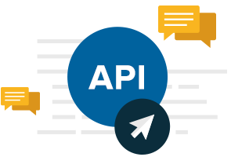
Fig 4.14SMS API

Send & Receive SMS
The SMS API enables users to send single or bulk SMS texts. Highly suited for service -related confirmations, updates & reminders. Also, for bulk SMS marketing campaigns.
HTTP API: It is used to send single/Multiple SMS from your application. It's typically a simple URL which you should call from your application to send SMS instantly. We can provide below API's
- Send SMS API: Use this API to send 1 or more SMS from your app, response will be a unique 'msgid'
- Delivery Report API: This API is used to check the delivery status of the SMS sent earlier, using 'msgid' parameter received from step (1).
- Balance Check API: Use this API to check the balance of your account any time.
- Receive SMS API: You can also receive SMS response/feedbacks in real-time using our Virtual Mobile Number or Short Code services

4.2.7. SIMPLE MAIL TRANSFER PROTOCOL
The Simple Mail Transfer Protocol (SMTP) is a technical standard for transmitting electronic mail (email) over a network. Like other networking protocols, SMTP allows computers and servers to exchange data regardless of their underlying hardware or software. Just as the use of a standardized form of addressing an envelope allows the postal service to operate, SMTP standardizes the way email travels from sender to recipient, making widespread email delivery possible.

Fig 4.15 SMTP

SMTP is a mail delivery protocol, not a mail retrieval protocol. A postal service delivers mail to a mailbox, but the recipient still has to retrieve the mail from the mailbox. Similarly, SMTP delivers an email to an email provider's mail server, but separate protocols are used to retrieve that email from the mail server so the recipient can read it.

Types of SMTP
RFC 5321 differentiates between four types of SMTP systems:
- Originating SMTP is the first system that interacts with the internet as it introduces mail;
- Delivery SMTP is the system that receives emails from the internet and delivers them to the recipients;
- Relay SMTP relays emails between SMTP servers or MTAs (more on transfer agent meaning below) without modifying the message in any way;
- Gateway SMTP or SMTP gateway also transfers emails between different servers but, unlike SMTP relay, it’s allowed to transform the message if needed. SMTP gateways are usually firewalls that rewrite addresses or intermediary SMTP servers.

CHAPTER 5

SYSTEM ARCHITECTURE
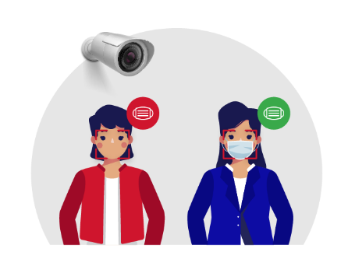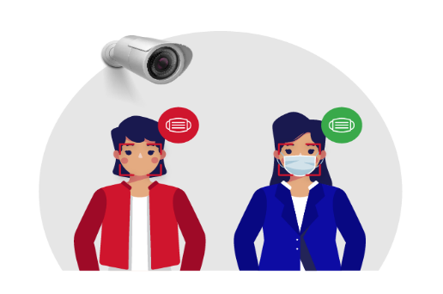
Student Face Enrollment
Capture Face
Convert into Frames
Preprocessing
RPN Face Detection
Feature Extraction
FRCNN Classification
College Database
Class Camera Capture Face
Prediction
Student in class room or other area
College Admin or Staff
Student

Add Student Details
Warning
Mark Attendance
Import Attendance in Excel Format
Canteen Camera Capture Face

Fig 5.1 System Architecture

CHAPTER 6

SYSTEM TESTING

6.1. SYSTEM TESTING

Software testing is a progression of processes that examine and assess the quality of software. It assures that software product is building by regulatory, technological, a business desires functional and user requirements. Software testing is a broad procedure that encompasses various connected procedures. Software completeness regarding functional requirements; discovering technological blunders and assuring the software is bug-free; analysing usability, performance, safety, localization, compatibility, and installation.
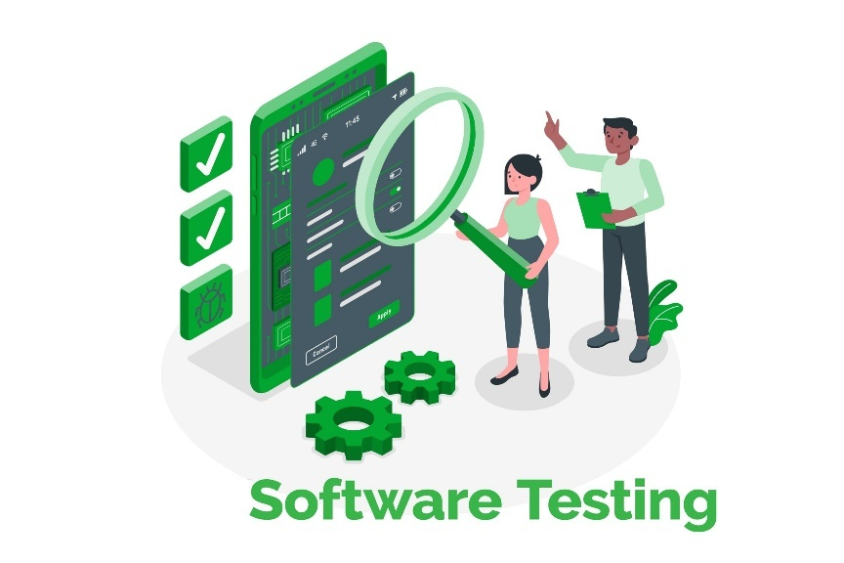
Fig 6.1 Software Testing

Software Testing Life Cycle is a process followed by software industries to test the software products. STLC is the acronym for Software Testing Life Cycle. STLC process is followed strictly to ensure quality products are delivered to the customers within the planned schedule and cost. Software testers will be highly involved in the testing process to make sure high standard software is developed. Whole Life Cycle defines and improves the overall software quality and test process.

6.1.1. Types of Testing
Making quality and performance an indispensable part of a quality assurance program brings software testing services in focus for many businesses. There are multiple types of software testing like agile testing, automation testing, unit testing, usability testing, acceptance testing, security testing, sanity testing, smoke testing, compatibility testing, ad hoc testing, integration testing, performance, and several other so types of software testing too. It is time to explore all types of software testing and get to know which one will help us resolve which type of flaws
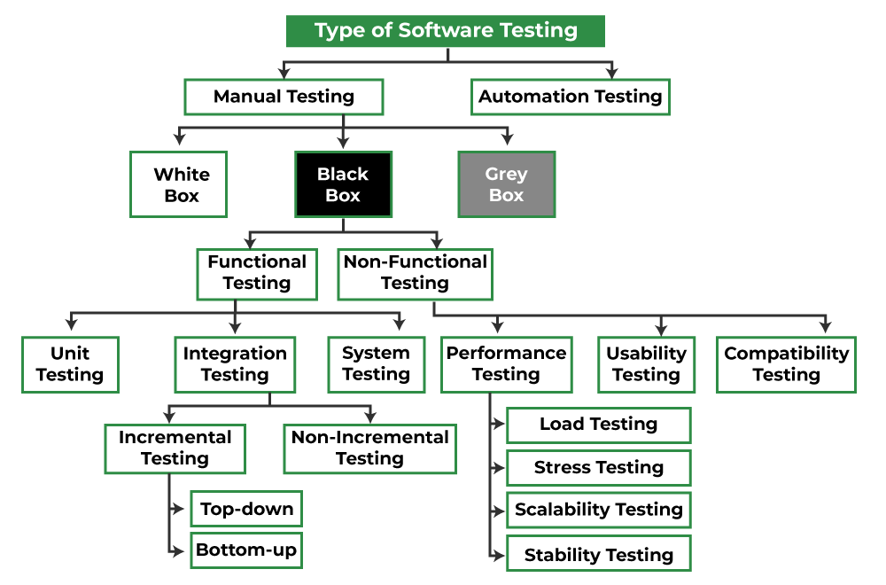
Fig 6.2 Types of Testing
Unit Testing
Unit testing is a software testing technique that focuses on testing individual units or components of the software in isolation. The main goal is to ensure that each unit functions as intended and meets its design specifications. It is primarily conducted by developers during the development phase.

Integration Testing
Integration testing is the next level of testing that follows unit testing. It tests the interactions between different units or components of the software to uncover defects in the interfaces and interactions. The purpose is to verify that integrated units work together as expected and that data flow and communication between modules are functioning correctly.

Functional Testing
Functional testing evaluates the software's functionality against the specified requirements. It includes black-box testing, where the internal logic and code structure are not known to the tester. The focus is on verifying that the software behaves as expected, performs the functions it is supposed to, and meets user requirements.

Non-Functional Testing
Non-functional testing, as the name suggests, focuses on non-functional aspects of the software. This includes testing for performance, scalability, reliability, and usability. Performance testing assesses how the software performs under different conditions, scalability testing evaluates its ability to handle increased load, reliability testing ensures its stability, and usability testing assesses the user-friendliness of the software.

Acceptance Testing
Acceptance testing, also known as user acceptance testing (UAT), is performed to validate that the software meets the business requirements and is acceptable for delivery to end-users. It is conducted by end-users or stakeholders to ensure that the software meets their expectations and business needs.

Usability Testing
Usability testing assesses the software's user-friendliness and ease of use from an end-user perspective. It focuses on evaluating factors such as navigation, accessibility, and intuitiveness to ensure that the software is easy to learn and operate.

Compatibility Testing
Compatibility testing ensures that the software functions correctly across different platforms, devices, browsers, and operating systems. It verifies that the software is compatible with various hardware configurations and software environments to provide a consistent user experience.

System Testing
System testing evaluates the entire software system as a whole to verify that it meets the specified requirements and functions correctly in a real-world environment. It involves testing the software's functionality, performance, security, and reliability against the system requirements.

6.1.2. TEST CASES
1. Test Case ID: TC_UI_001
Input: College Admin Login with valid credentials
Expected Result: College Admin successfully logged in
Actual Result: College Admin successfully logged in
Status: Passed

2. Test Case ID: TC_UI_002
Input: Add and Manage Department
Expected Result: Department added and managed successfully
Actual Result: Department added and managed successfully
Status: Passed

3. Test Case ID: TC_UI_003
Input: Add and Manage Semester and Syllabus Details
Expected Result: Semester and syllabus details added and managed successfully
Actual Result: Semester and syllabus details added and managed successfully
Status: Passed

4. Test Case ID: TC_UI_004
Input: Add and Manage Student Details
Expected Result: Student details added and managed successfully
Actual Result: Student details added and managed successfully
Status: Passed

5. Test Case ID: TC_UI_005
Input: Add and Manage Staff Details
Expected Result: Staff details added and managed successfully
Actual Result: Staff details added and managed successfully
Status: Passed

6. Test Case ID: TC_UI_006
Input: Provide Login Credential
Expected Result: Login credentials provided successfully
Actual Result: Login credentials provided successfully
Status: Passed

7. Test Case ID: TC_UI_007
Input: Enroll Student Face
Expected Result: Student face enrolled successfully
Actual Result: Student face enrolled successfully
Status: Passed

8. Test Case ID: TC_UI_008
Input: Timetable Management
Expected Result: Timetable managed successfully
Actual Result: Timetable managed successfully
Status: Passed

9. Test Case ID: TC_UI_009
Input: View Attendance
Expected Result: Attendance viewed successfully
Actual Result: Attendance viewed successfully
Status: Passed

10. Test Case ID: TC_UI_010
Input: Generate Report
Expected Result: Report generated successfully
Actual Result: Report generated successfully
Status: Passed

11. Test Case ID: TC_UI_011
Input: Customize Notification
Expected Result: Notification customized successfully
Actual Result: Notification customized successfully
Status: Passed
12. Test Case ID: TC_UI_012
Input: Staff Login with valid credentials
Expected Result: Staff successfully logged in
Actual Result: Staff successfully logged in
Status: Passed

13. Test Case ID: TC_UI_013
Input: View Timetable
Expected Result: Timetable viewed successfully
Actual Result: Timetable viewed successfully
Status: Passed

14. Test Case ID: TC_UI_014
Input: View Student Attendance
Expected Result: Student attendance viewed successfully
Actual Result: Student attendance viewed successfully
Status: Passed

15. Test Case ID: TC_UI_015
Input: View Class Skipper Details with Image
Expected Result: Class skipper details viewed with images successfully
Actual Result: Class skipper details viewed with images successfully
Status: Passed

16. Test Case ID: TC_UI_016
Input: HoD Login with valid credentials
Expected Result: HoD successfully logged in
Actual Result: HoD successfully logged in
Status: Passed

17. Test Case ID: TC_UI_017
Input: View Timetable
Expected Result: Timetable viewed successfully
Actual Result: Timetable viewed successfully
Status: Passed

18. Test Case ID: TC_UI_018
Input: View Student Attendance
Expected Result: Student attendance viewed successfully
Actual Result: Student attendance viewed successfully
Status: Passed

19. Test Case ID: TC_UI_019
Input: View Class Skipper Details with Image
Expected Result: Class skipper details viewed with images successfully
Actual Result: Class skipper details viewed with images successfully
Status: Passed

20. Test Case ID: TC_UI_020
Input: Send SMS to Parents
Expected Result: SMS sent to parents successfully
Actual Result: SMS sent to parents successfully
Status: Passed
6.1.3. TEST REPORT
Introduction
The purpose of this test report is to document the results of the user interface testing conducted for the College Surveillance System. The system aims to provide comprehensive surveillance and attendance management solutions for educational institutions.
Test Objective
The objective of this testing is to ensure that the user interface functionalities meet the specified requirements and perform as expected.
Test Scope
This test report covers the user interface testing for the following modules:
- College Admin Dashboard
- Staff Dashboard
- HoD Dashboard
Test Environment
The testing was conducted in the following environment:
- Operating System: Windows 10
- Browser: Google Chrome, Mozilla Firefox
- Devices: Desktop, Laptop
Test Result
The test results are summarized as follows:
- College Admin Dashboard
  - Login: Passed
  - Add and Manage Department: Passed
  - Add and Manage Semester and Syllabus Details: Passed
  - Add and Manage Student Details: Passed
  - Add and Manage Staff Details: Passed
  - Provide Login Credential: Passed
  - Enroll Student Face: Passed
  - Timetable Management: Passed
  - View Attendance: Passed
  - Generate Report: Passed
  - Customize Notification: Passed
- Staff Dashboard
  - Login: Passed
  - View Timetable: Passed
  - View Student Attendance: Passed
  - View Class Skipper Details with Image: Passed
- HoD Dashboard
  - Login: Passed
  - View Timetable: Passed
  - View Student Attendance: Passed
  - View Class Skipper Details with Image: Passed
  - Send SMS to Parents: Passed
Test Conclusion
Overall, the user interface testing for the College Surveillance System has been successful. All specified functionalities have been tested and have met the expected criteria. The system demonstrates usability, functionality, and reliability in providing surveillance and attendance management solutions for educational institutions.

CHAPTER 7

IMPLEMENTATION

7.1 PROJECT DESCRIPTION

The proposed system of the project is a technologically advanced solution for educational institutions, integrating state-of-the-art features to address challenges in attendance management and campus security. Leveraging cutting-edge technologies like FaceNet for precise face recognition and Faster R-CNN for behavioral analysis, the system introduces a comprehensive approach to automate attendance processes. Facilitated by FaceNet, the attendance automation module ensures accuracy and efficiency, significantly reducing reliance on traditional manual methods. Real-time face identification during live video feeds further enhances the precision of attendance tracking. Concurrently, Faster R-CNN is employed for proactive behavioral analysis, detecting patterns such as class skipping or unusual activities. This functionality provides educators with valuable insights, allowing for early intervention and improved student engagement. The inclusion of a Violation Alert System adds an extra layer of security, triggering immediate alerts in response to unauthorized activities, such as students wandering during class hours. The robust notification system ensures transparent communication, promptly updating stakeholders on attendance events, violations, and critical information through various channels like SMS, emails, and in-app messages. Administrative oversight is streamlined through a centralized dashboard, offering a holistic view of departmental management, semesters, student details, timetables, and notifications. Tailored user interfaces cater to different roles within the educational institution, ensuring an intuitive and user-friendly experience for College Admin, Staff, and HoD. The real-time face identification module operates seamlessly during live video feeds, contributing to the overall efficiency of attendance processes. Designed to be adaptable and scalable, the system accommodates various educational settings and future growth, making it a versatile solution for diverse institutions. In essence, the proposed College Surveillance System aims to revolutionize attendance management, enhance campus security, and provide valuable behavioral insights for an improved educational experience.

7.2. SYSTEM FLOW
- Video Capture
  - Cameras installed across the college campus continuously capture video footage.

- Frame Extraction
  - Video footage is processed to extract individual frames, creating a sequence of images.

- Face Detection
  - Each frame undergoes face detection using a pre-trained model, isolating detected faces.

- Image Preprocessing
  - Preprocessing steps enhance the quality of detected faces, including resizing, normalization, and denoising.

- Face Recognition (FaceNet)
  - Preprocessed faces are passed through the FaceNet model for feature extraction and embedding.

- Attendance Automation
  - The system compares obtained face embeddings with the database to automatically mark attendance.

- Violation Detection
  - Student behavior during class hours is monitored, and violations, such as roaming, are detected.

- Alert Generation
  - Alerts are generated for detected violations, providing details and time stamped images.

- Notification
  - Automated notifications are sent to stakeholders based on attendance data, violations, or specific events.
- Data Storage
  - Processed data, attendance records, and surveillance footage are stored in a database.

- Reporting and Analysis
  - Administrators access a dashboard to view attendance reports, violation details, and analytics.

- User Interaction
  - Users interact with the system through a user-friendly dashboard or application for monitoring and management.

- Deployment with College Dashboard
  - The trained FaceNet model is seamlessly integrated into the College Dashboard for practical use.

MODULES DESCRIPTION
1. College Management Dashboard
In this module we developed web browser-based interface designed to be used by college admin, Teaching Staff and Student– untrained in data science – to predict and detect face with mask and no mask for attendance System. It is a cloud based educational ERP software that enables higher education institutions & colleges to manage online admission, student enrolment, students’ attendance, online fees, grades, assignments, library books, etc. Hosted on cloud, this college ERP helps educators to streamline all the core activities with the latest technology stack such as biometrics, business intelligence tools & analytics dashboard that generates precise reports on college admission, enrolment, scholarship, previous academic record, domicile, fees, alerts, attendance and compliance management.

2. End User
2.1. College Admin Dashboard
- Login Page
Secure login page for College Admin with username and password fields.

- Admin Home Page
Centralized dashboard for College Admin to manage departments, semesters, syllabus, students, staff, login credentials, face enrollment, timetable, attendance viewing, report generation, and notification customization.

- Department Management
Page for adding and managing departments with an organized list of existing
departments.

- Semester Management
Page for adding and managing semesters with options to edit or delete existing entries.

- Syllabus Management
Form to manage and organize syllabus details, including an editable list of existing
entries.

- Student Management
Form for adding and managing student details, coupled with a list and options to edit or
delete.

- Staff Management
Form for adding and managing staff details with an organized list for easy editing or
deletion.

- Login Credentials
Interface for College Admin to provide login credentials for staff and HoD.

- Enroll Student Face
Dedicated page for capturing and enrolling student faces for attendance.

- Timetable Management
Functionality to manage and organize class timetables for different departments and
semesters.

- View Attendance
Page to select department, semester, and date for viewing attendance records in a tabular
format.

- Generate Report
Form to select parameters for generating attendance reports with downloadable options.

- Customize Notification
Form to customize and send notifications with options for recipients and message
content.

2.2. Staff Dashboard
- Login Page
Secure login portal for staff members with appropriate credentials.

- Staff Home Page
Dashboard for staff to view timetable, student attendance, class skipper details, and
images of roaming students.

- View Timetable
Page displaying the timetable for the staff member's classes.

- View Attendance
Page to select department, semester, and date to view attendance records in a tabular
format.

- Class Skipper Details
Page displaying details of students who have skipped classes, including images and
additional information.

- View Image of Students Roaming
Page displaying images of students found roaming around the college during class
hours.

2.3. HoD Dashboard
- Login Page
Secure login portal for the Head of the Department (HoD) with proper credentials.

- HoD Home Page
Dashboard for HoD to view timetable, student attendance, class skipper details, and
images of roaming students.

- View Timetable
Page displaying the timetable for the HoD's department.

- View Attendance
Page to select department, semester, and date to view attendance records in a tabular
format.

- Class Skipper Details
Page displaying details of students who have skipped classes, including images and
additional information.

- View Image of Students Roaming
Page displaying images of students found roaming around the college during class
hours.

- Send SMS to Parents
Functionality allowing HoD to send SMS notifications to parents regarding their ward's
attendance or behavior.

3.1. Capture Live Fac
This module is initial part of the system. Logitech C270 (3MP) is used for image
acquisition.

3.2. Pre-processing
Face Image pre-processing are the steps taken to format images before they are used by
model training and inference. The steps to be taken are:
- Read image
- RGB to Grey Scale conversion
- Resize image
Original size (360, 480, 3) — (width, height, no. RGB channels)
Resized (220, 220, 3)
- Remove noise (Denoise)
smooth our image to remove unwanted noise. We do this using gaussian blur.
- Binarization
Image binarization is the process of taking a grayscale image and converting it to black-and-white, essentially reducing the information contained within the image from 256 shades of grey to 2: black and white, a binary image.

4. Face Identification
4.1 Live Feed from Class and Campus
This module establishes a continuous monitoring system by providing real-time video feeds from classrooms and various areas within the campus. The live feed integration allows for constant surveillance, enabling the system to capture events and activities as they unfold. This real-time aspect enhances the overall responsiveness of the Face Identification module, providing administrators with up-to-the-minute insights into student attendance and campus activities.

4.2 Face Recognition and Identification:
Powered by FaceNet, this component is pivotal for accurate attendance tracking and security enhancement. As live video feeds are received, the Face Identification module utilizes advanced facial recognition algorithms to identify and authenticate individuals in real time. The model compares captured facial features with the pre-trained facial database, ensuring precise identification. This not only automates attendance processes with a high level of accuracy but also contributes to campus security measures by instantly recognizing and validating individuals within the monitored areas. The utilization of FaceNet technology ensures a robust and efficient face recognition process, enhancing the reliability of the overall College Surveillance System. By seamlessly integrating live video feeds with state-of-the-art facial recognition capabilities, this component plays a key role in creating a secure and technologically advanced environment within the educational institution.

5. Attendance Automation
The Attendance Automation module stands as a pivotal component within the College Surveillance System, revolutionizing the traditional method of attendance management. By harnessing the power of advanced facial recognition technology, this module automates the attendance marking process, eliminating the need for manual recording. Employing the highly precise facial recognition capabilities of FaceNet, the system ensures accurate identification of individuals in real-time during live video feeds. This immediate and continuous updating of attendance records not only enhances accuracy but also significantly reduces the administrative burden associated with conventional attendance tracking methods. Integration with the College Admin Dashboard allows for effortless access to attendance records, generating reports and facilitating data-driven decision-making. This integration enhances overall efficiency, saving valuable time for educators and administrative staff. The tamper-resistant automated system guarantees accurate and verifiable attendance records; each linked to the identified face. Designed with a user-friendly interface, the module ensures easy navigation for educators and administrators, contributing to the seamless integration of the automated system into existing workflows. In essence, the Attendance Automation module not only brings precision and efficiency to attendance management but also enhances the overall experience for users, aligning with the broader goal of creating a technologically advanced and user-friendly surveillance system within the educational institution.

6. Violation Alert
The Violation Alert module within the College Surveillance System plays a critical role in maintaining a secure and disciplined learning environment. This proactive component continuously monitors student behavior and attendance patterns during designated class hours. The module employs advanced behavioral analysis to identify potential violations, such as students wandering or engaging in unauthorized activities within monitored areas. Upon detecting such violations, the system triggers immediate alerts, ensuring swift intervention by educators or administrators. To enhance the reliability of these alerts, the module captures images during violation instances, providing visual verification for administrators to assess the situation accurately.

In addition to real-time alerts, the module includes a robust reporting mechanism that logs all detected violations. This comprehensive record enables administrators to analyze patterns, implement preventive measures, and maintain a disciplined learning environment. The Violation Alert module seamlessly integrates with the overall notification system, ensuring alerts are communicated through various channels like SMS, emails, or in-app messages. This multi-channel approach enhances the likelihood of timely acknowledgment and response. In essence, the Violation Alert module goes beyond traditional attendance tracking, actively contributing to the creation of a secure, disciplined, and conducive learning environment within the educational institution. Its proactive monitoring and swift alerting mechanisms make it an essential component in ensuring the overall safety and discipline of the campus.

7. Notification
The Notification module within the College Surveillance System automates communication by sending timely updates to stakeholders based on attendance data, detected violations, and specific events. With customizable settings for administrators, faculty, and parents, this module ensures personalized notifications, fostering efficient and transparent communication. Whether alerting about attendance-related activities or violations, the system delivers information through various channels, such as SMS, emails, or in-app messages. This feature-rich module enhances collaboration, awareness, and engagement within the educational community, promoting a secure and well-informed learning environment.

8. Reports
The Reports module in the College Surveillance System serves as a vital tool for generating detailed insights into attendance, behavioural patterns, and violation instances. Administrators can access customizable reports through the centralized dashboard, enabling them to analyse attendance trends, gain deeper insights into student behaviour during class hours, and document violation instances. This data-driven approach empowers administrators to make informed decisions, implement proactive interventions, and continually enhance the educational environment. The Reports module stands as a valuable resource for fostering continuous improvement and ensuring a disciplined and engaging learning atmosphere.

CHAPTER 8

CONCLUSION &FUTURE ENHANCEMENT

This study proposes a robust, accurate, and secure facial recognition-based automated attendance system that enhances efficiency and eliminates the drawbacks of traditional attendance-taking processes. With the application of real-time detection, machine learning algorithms, and security measures, accuracy, punctuality, and data security are ensured, and manual workload is reduced. The findings of this research confirm that face recognition technology significantly outperforms conventional methods such as roll calls, RFID tracking, and fingerprint readers in terms of speed, accuracy, and user convenience. Additionally, the application of local binary pattern histogram (LBPH) for feature extraction has been successful in handling varying lighting conditions, hence making the system more resilient for real-world deployment. Outside of the campus setting, this system can be used in business offices, government ministries, and secure areas, where auto-verification and monitoring of presence are necessary. Future developments can be directed at multi-modal biometric verification, where face recognition can be integrated with iris or voice verification for enhanced security and accuracy. Cloud storage and remote access can also be implemented to enable maximum scalability and ease of use so that the system can be deployed on a large scale. By addressing accuracy, security, and usability problems, this research adds to the new field of AI-based biometric authentication systems. It opens the gates for future innovations in automated attendance management systems that could be adopted by schools, organizations, and security-aware environments around the globe.

APPENDIX-1
9.1 SAMPLE CODEING
Packages
from flask import Flask, render_template, Response, redirect, request, session, abort, url_for
from camera import VideoCamera
import cv2
import shutil
import datetime
import PIL.Image
from PIL import Image
import imagehash
import mysql.connector
import time
import imutils
import argparse
import shutil
Database Connection
mydb = mysql.connector.connect(
host="localhost",
user="root",
password="",
charset="utf8",
database="class_skipper"
Login
def login():
msg=""
if request.method=='POST':
uname=request.form['uname']
pwd=request.form['pass']
cursor = mydb.cursor()
cursor.execute('SELECT * FROM admin WHERE username = %s AND password = %s', (uname, pwd))
account = cursor.fetchone()
if account:
session['username'] = account['username']
return redirect(url_for('admin'))
else:
# Account doesnt exist or username/password incorrect
msg = 'Incorrect username/password!'
return render_template('login.html',msg=msg)
Add Student
def add_student():
#import student
msg=""
mycursor = mydb.cursor()
mycursor.execute("SELECT * FROM department")
value1 = mycursor.fetchall()
if request.method=='POST':
name=request.form['name']
mobile=request.form['mobile']
email=request.form['email']
address=request.form['address']
aadhar=request.form['aadhar']
regno=request.form['regno']
dept=request.form['dept']
year=request.form['year']
parent_mob=request.form['parent_mob']
mycursor.execute("SELECT count(*) FROM register where regno=%s",(regno,))
cnt = mycursor.fetchone()[0]
if cnt==0:
mycursor.execute("SELECT max(id)+1 FROM register")
maxid = mycursor.fetchone()[0]
if maxid is None:
maxid=1
sql = "INSERT INTO register(id,name,mobile,email,address,aadhar,regno,dept,year,parent_mob) VALUES (%s, %s, %s, %s, %s, %s,%s, %s, %s, %s)"
val = (maxid,name,mobile,email,address,aadhar,regno,dept,year,parent_mob)
mycursor.execute(sql, val)
mydb.commit()
return redirect(url_for('add_photo',vid=maxid))
Training
image = cv2.imread('static/dataset/'+fname)
original = image.copy()
kmeans = kmeans_color_quantization(image, clusters=4)
# Convert to grayscale, Gaussian blur, adaptive threshold
gray = cv2.cvtColor(kmeans, cv2.COLOR_BGR2GRAY)
blur = cv2.GaussianBlur(gray, (3,3), 0)
thresh = cv2.adaptiveThreshold(blur,255,cv2.ADAPTIVE_THRESH_GAUSSIAN_C, cv2.THRESH_BINARY_INV,21,2)
# Draw largest enclosing circle onto a mask
mask = np.zeros(original.shape[:2], dtype=np.uint8)
cnts = cv2.findContours(thresh, cv2.RETR_EXTERNAL, cv2.CHAIN_APPROX_SIMPLE)
cnts = cnts[0] if len(cnts) == 2 else cnts[1]
cnts = sorted(cnts, key=cv2.contourArea, reverse=True)
for c in cnts:
((x, y), r) = cv2.minEnclosingCircle(c)
cv2.circle(image, (int(x), int(y)), int(r), (36, 255, 12), 2)
cv2.circle(mask, (int(x), int(y)), int(r), 255, -1)
break
# Bitwise-and for result
result = cv2.bitwise_and (original, original, mask=mask)
result[mask==0] = (0,0,0)
path_main = 'static/dataset'
for fname in os.listdir(path_main):
##RPN
img = cv2.imread('static/trained/g_'+fname)
gray = cv2.cvtColor(img,cv2.COLOR_BGR2GRAY)
ret, thresh = cv2.threshold(gray,0,255,cv2.THRESH_BINARY_INV+cv2.THRESH_OTSU)
kernel = np.ones((3,3),np.uint8)
opening = cv2.morphologyEx(thresh,cv2.MORPH_OPEN,kernel, iterations = 2)
# sure background area
sure_bg = cv2.dilate(opening,kernel,iterations=3)
# Finding sure foreground area
dist_transform = cv2.distanceTransform(opening,cv2.DIST_L2,5)
ret, sure_fg = cv2.threshold(dist_transform,1.5*dist_transform.max(),255,0)
# Finding unknown region
sure_fg = np.uint8(sure_fg)
segment = cv2.subtract(sure_bg,sure_fg)
img = Image.fromarray(img)
segment = Image.fromarray(segment)
def kmeans_color_quantization(image, clusters=8, rounds=1):
h, w = image.shape[:2]
samples = np.zeros([h*w,3], dtype=np.float32)
count = 0
for x in range(h):
for y in range(w):
samples[count] = image[x][y]
count += 1
compactness, labels, centers = cv2.kmeans(samples,
clusters,
None,
(cv2.TERM_CRITERIA_EPS + cv2.TERM_CRITERIA_MAX_ITER, 10000, 0.0001),
rounds,
cv2.KMEANS_RANDOM_CENTERS)
centers = np.uint8(centers)
res = centers[labels.flatten()]
return res.reshape((image.shape))
#Feature Extraction-Local Binary Patterns (LBP)
###FR
id = 0
recognizer = cv2.face.LBPHFaceRecognizer_create()
recognizer.read('trainer/trainer.yml')
cascadePath = "haarcascade_frontalface_default.xml"
faceCascade = cv2.CascadeClassifier(cascadePath);

font = cv2.FONT_HERSHEY_SIMPLEX
gray = cv2.cvtColor(image,cv2.COLOR_BGR2GRAY)
faces = faceCascade.detectMultiScale(
gray,
scaleFactor = 1.2,
minNeighbors = 5,
minSize = (int(self.minW), int(self.minH)),
#FR-CNN – Face Identification
def FRCNN():
C.use_horizontal_flips = bool(options.horizontal_flips)
C.use_vertical_flips = bool(options.vertical_flips)
C.rot_90 = bool(options.rot_90)
C.model_path = options.output_weight_path
model_path_regex = re.match("^(.+)(\.hdf5)$", C.model_path)
if model_path_regex.group(2) != '.hdf5':
print('Output weights must have .hdf5 filetype')
exit(1)
C.num_rois = int(options.num_rois)
if options.network == 'vgg':
C.network = 'vgg'
from keras_frcnn import vgg as nn
elifoptions.network == 'resnet50':
from keras_frcnn import resnet as nn
C.network = 'resnet50'
else:
print('Not a valid model')
raise ValueError
if options.input_weight_path:
C.base_net_weights = options.input_weight_path
else:
# set the path to weights based on backend and model
C.base_net_weights = nn.get_weight_path()
train_imgs, classes_count, class_mapping = get_data(options.train_path)
val_imgs, _, _ = get_data(options.train_path)
if 'bg' not in classes_count:
classes_count['bg'] = 0
class_mapping['bg'] = len(class_mapping)
C.class_mapping = class_mapping
inv_map = {v: k for k, v in class_mapping.items()}
print('Training images per class:')
pprint.pprint(classes_count)
print(f'Num classes (including bg) = {len(classes_count)}')
config_output_filename = options.config_filename
with open(config_output_filename, 'wb') as config_f:
pickle.dump(C,config_f)
print(f'Config has been written to {config_output_filename}, and can be loaded when testing to ensure correct results')
random.shuffle(train_imgs)
num_imgs = len(train_imgs)
data_gen_train = data_generators.get_anchor_gt(train_imgs, classes_count, C, nn.get_img_output_length, K.common.image_dim_ordering(), mode='train')
data_gen_val = data_generators.get_anchor_gt(val_imgs, classes_count, C, nn.get_img_output_length,K.common.image_dim_ordering(), mode='val')
if K.common.image_dim_ordering() == 'th':
input_shape_img = (3, None, None)
else:
input_shape_img = (None, None, 3)
img_input = Input(shape=input_shape_img)
roi_input = Input(shape=(None, 4))
shared_layers = nn.nn_base(img_input, trainable=True)
num_anchors = len(C.anchor_box_scales) * len(C.anchor_box_ratios)
rpn = nn.rpn(shared_layers, num_anchors)
classifier = nn.classifier(shared_layers, roi_input, C.num_rois, nb_classes=len(classes_count), trainable=True)

APPENDIX-II
10.1. SCREEN SHOTS

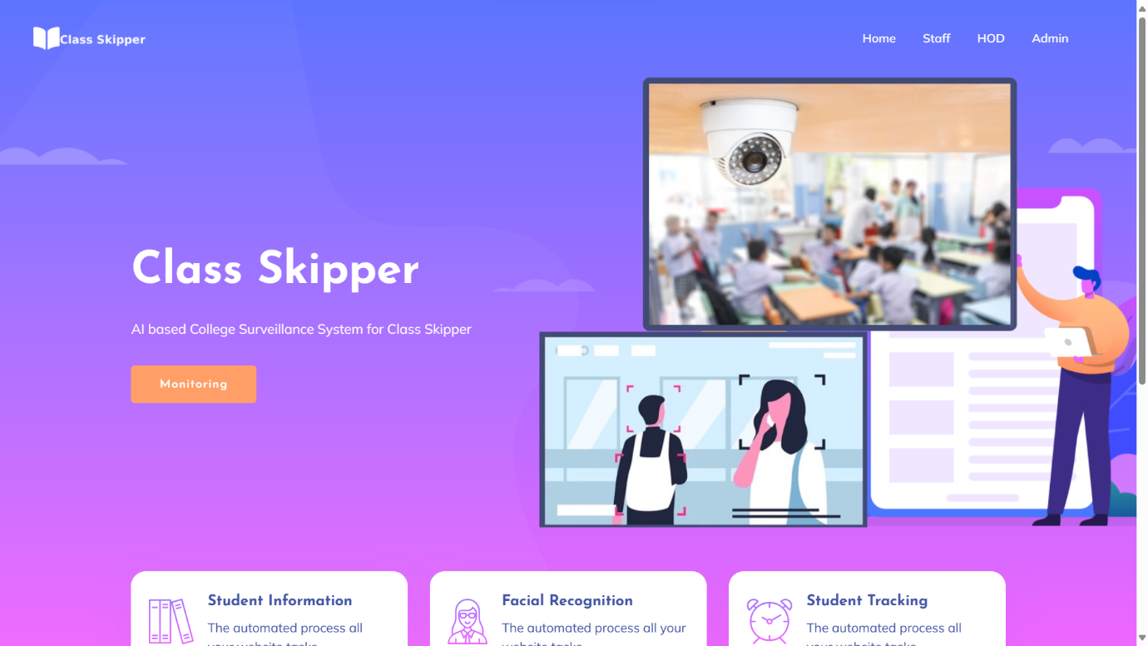

REFERENCES

[1] S. Ennajar and W. Bouarifi, “Monitoring Student Attendance Through Vision Transformer-Based Iris Recognition,” International Journal of Advanced Computer Science and Applications (IJACSA), vol. 15, no. 2, pp. 101–107, 2024.
[2] B.-T. Nguyen-Tat, M.-Q. Bui, and V. M. Ngo, “Automating Attendance Management in Human Resources: A Design Science Approach Using Computer Vision and Facial Recognition,” arXiv preprint, arXiv:2405.12633, 2024.
[3] E. Bugingo, “Enhancing Face Recognition Attendance System Utilizing Real-Time Face Tracking to Ensure Accuracy and Reliability in Attendance Tracking,” ScienceDirect Journal of Computer Vision Applications, vol. 18, no. 4, pp. 225–233, 2025.
[4] K. B. Dharmaraj, D. C. N. Dhanushree, R. H. V., S. N., and T. P. M., “Real-Time Student Face Recognition Attendance System Using AI,” International Advanced Research Journal in Science, Engineering and Technology (IARJSET), vol. 12, no. 5, pp. 80–85, 2025.
[5] “Smart AI-Based Attendance Monitoring System Using YOLOv8,” ResearchGate Preprint, DOI: 10.13140/RG.2.2.11346.52161, 2025.
[6] “AI-Powered Security and Attendance Management System,” Journal of Information Systems Engineering and Management (JISEM), vol. 10, no. 35s, pp. 221–228, 2025.
[7] G. V. S. Suhas, “Real-Time Student Attendance System with Emotion and Feedback Analysis,” Indiana Journal of Multidisciplinary Research, vol. 4, no. 3, pp. 36–42, 2024.
[8] K. Ishaq and S. Bibi, “IoT-Based Smart Attendance System Using RFID: A Systematic Literature Review,” arXiv preprint, arXiv:2308.02591, 2023.
[9] A. Narkhede, M. Menon, and V. Pillai, “Facial Recognition and Machine Learning-Based Student Monitoring System,” Semantic Scholar, 2023.
[10] “Automated Attendance Management Using Computer Vision,” International Advanced Research Journal in Science, Engineering and Technology (IARJSET), vol. 11, issue 5, pp. 110–115, 2024.
[11] “AI-Based Smart Attendance Management System,” International Journal of Innovative Science and Research Technology (IJISRT), vol. 10, no. 4, pp. 745–752, 2025.
[12] G. Ramesh and R. Arul, “Deep Learning Approach for Automated Attendance Monitoring Using CNN,” IEEE International Conference on Intelligent Systems and Smart Infrastructure (ICISSI), pp. 312–317, 2023.
[13] P. Kumar and V. S. Rao, “AI-Enabled Campus Surveillance Using Edge Computing and YOLOv5,” IEEE Access, vol. 12, pp. 98765–98772, 2024.
[14] M. A. Rahman, “Face Recognition-Based Classroom Monitoring System Using Deep CNN,” International Journal of Computer Applications, vol. 185, no. 45, pp. 30–36, 2023.
[15] “AI-Based Surveillance and Tracking System Using DeepSORT and YOLO,” International Research Journal of Engineering and Technology (IRJET), vol. 10, no. 9, pp. 540–546, 2024.
[16] H. L. Sharma and K. Raj, “Cloud-Based Facial Recognition System for Attendance and Behavior Analysis,” IEEE Transactions on Artificial Intelligence in Education, vol. 4, no. 1, pp. 95–102, 2024.
[17] “Face Recognition Attendance System Using Python and OpenCV,” IARJSET Journal, vol. 10, issue 3, pp. 58–63, 2024.
[18] T. Zhang and L. Li, “AI-Driven Human Detection and Tracking in Campus Surveillance,” Springer Lecture Notes in Computer Science, vol. 14852, pp. 411–422, 2023.
[19] R. Kumar and A. Sinha, “Multi-Camera Person Tracking for Educational Surveillance Using Deep Learning,” IEEE Access, vol. 13, pp. 12041–12049, 2025.
[20] “Automated Attendance Monitoring System Using Real-Time Facial Recognition and Computer Vision,” ResearchGate Preprint, DOI: 10.13140/RG.2.2.22517.44806, 2024.

